University of Melbourne Student Union
Petitioned Meeting of the Creative Arts Committee
[1:00PM, Tuesday, 30/04/2019]
Location: Creative Arts Office, Level One Union House

- Procedural Matters
  - Meeting opened at 1:22pm
  - Election of Chair
Motion 1: That Lucy Holz be elected Chair
Mover: Lucy Holz Seconder: Ellie Hamill
CARRIED / NOT CARRIED / CARRIED WITHOUT DISSENT
  - Acknowledgement of Indigenous Owners
We acknowledge that this meeting takes place on the land of the Wurundjeri and Bunurong people and pay our respects to their elders past and present. Sovereignty was never ceded.
  - Attendance
“I, Nicholas Kirkby, a Creative Arts Committee member, petition to have this special meeting on Tuesday, the 30th of April at 1pm in the Creative Arts Office”
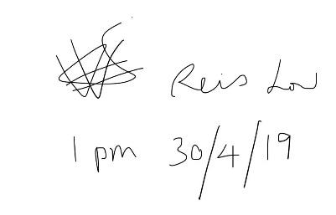
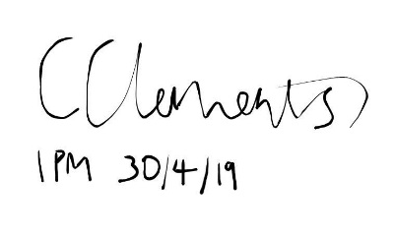

  - Apologies
Lucy Seale
  - Proxies
  - Membership
  - Adoption of Agenda
Motion 2: That the agenda be adopted as presented
Mover: Lucy Holz Seconder: Nicholas Kirkby
CARRIED / NOT CARRIED / CARRIED WITHOUT DISSENT

- Confirmation of Previous Minutes

Motion 3: That the previous minutes be confirmed as a true and accurate representation of our last meeting.
Mover: Lucy Holz Seconder: Ellie Hamill
CARRIED / NOT CARRIED / CARRIED WITHOUT DISSENT

- Matters Arising from the Minutes - Nil
- Correspondence
- Memorandum of Understanding
We are required to hold meetings once monthly/fortnightly during semester – confirm future meetings (priority)
You are required to be in regular attendance. If you miss three meetings in a row you are may be removed from the committee.
Expectations:
Listen to each other with respect and consideration.
Be aware that we will have differences of opinion & perspective.
Contribute positively and productivity.
Speak your mind, share your knowledge & understanding with the group.
- Arts Office Report
  - Past Events
- Lots of meetings and report writing for AGMs and Councils and such
- Lucy did her first TOOYA, Ellie has her first TOOYA on Thursday
- We went to Theatreboard
6.2 Mudfest Update:
Mudfest – Semester 2 – August 21st – 28th 2019
  - Mudfest Festival Team all chosen and had first full team meeting on Monday 15th of April
  - Mudfest Mentor Meetings regularly
  - Artist Call out OPEN – opened April 8th and will CLOSE on Monday 13th of May at 9AM
    - Artist Info Session Soon this Friday on 3rd of May, 11am – 12:30pm in the Ida Bar
Other
No current grant applications or inquiries, plan to extend deadline for this grant round – up for discussion until when – discussed as potentially making Friday 24th May
- Motions on Notice

Motion 7.1: To approve the spending of $31.25 for the boosting of the Artist Application Facebook Event for 14 days from the Mudfest Budget from Budget Line Advertising [3231]
Mover: Lucy Holz Seconder: Nicholas Kirkby
CARRIED / NOT CARRIED / CARRIED WITHOUT DISSENT

Motion 7.2: To approve the spending of $52,000 on bulk for the payment of Mudfest Contract staff from Budget Line [3011] excluding the payment of the Mudfest Frontline Team as they are yet to be hired
Mover: Lucy Holz Seconder: Fiona Xia
CARRIED / NOT CARRIED / CARRIED WITHOUT DISSENT
Noted: Nicholas Kirkby abstained as he is a member of the festival team and will be paid

- Motions not on Notice
- Other Business
- Next Meeting
Friday 17th May 10am - Creative Arts Office
- Close

